Examples:

Standard Form: y=ax2+bx+c

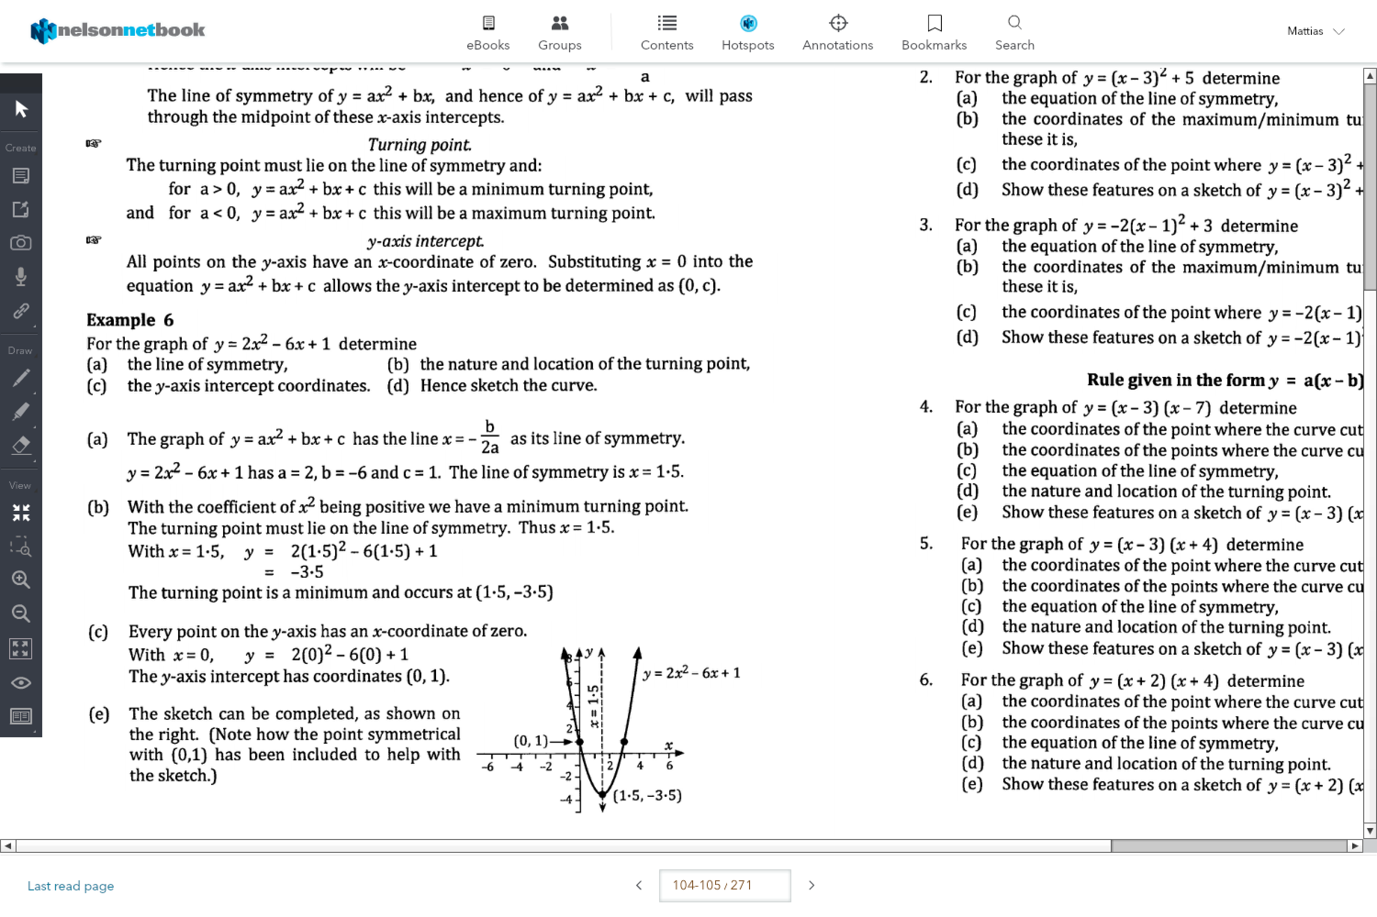

Turning Point Form: y=a(x-p)2+q

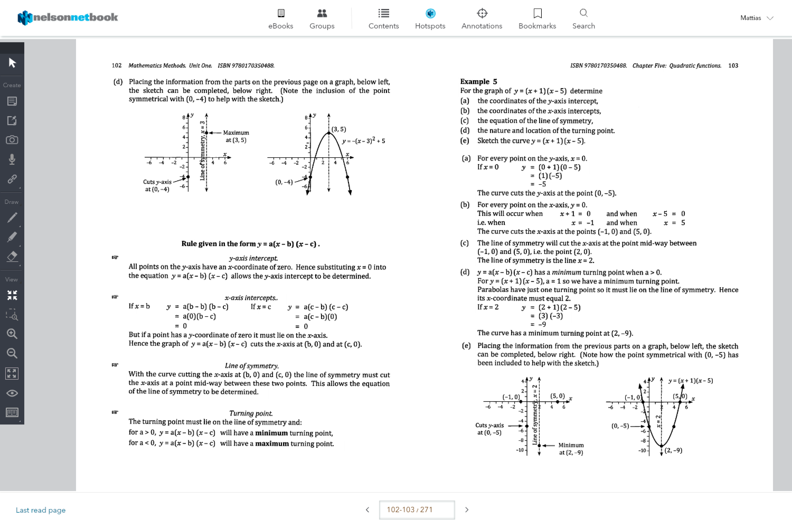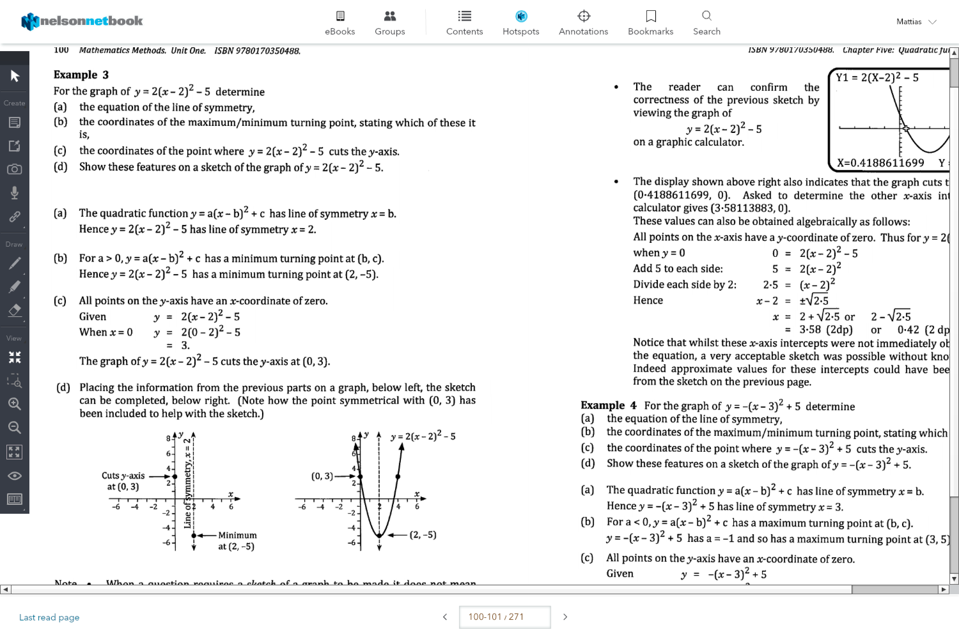

Root Form: y=a(x-r1­)(x-r­2)

**Table of Values:**

Quadratic functions have constant second *differences* in a table of values

A formula table for standard form is:

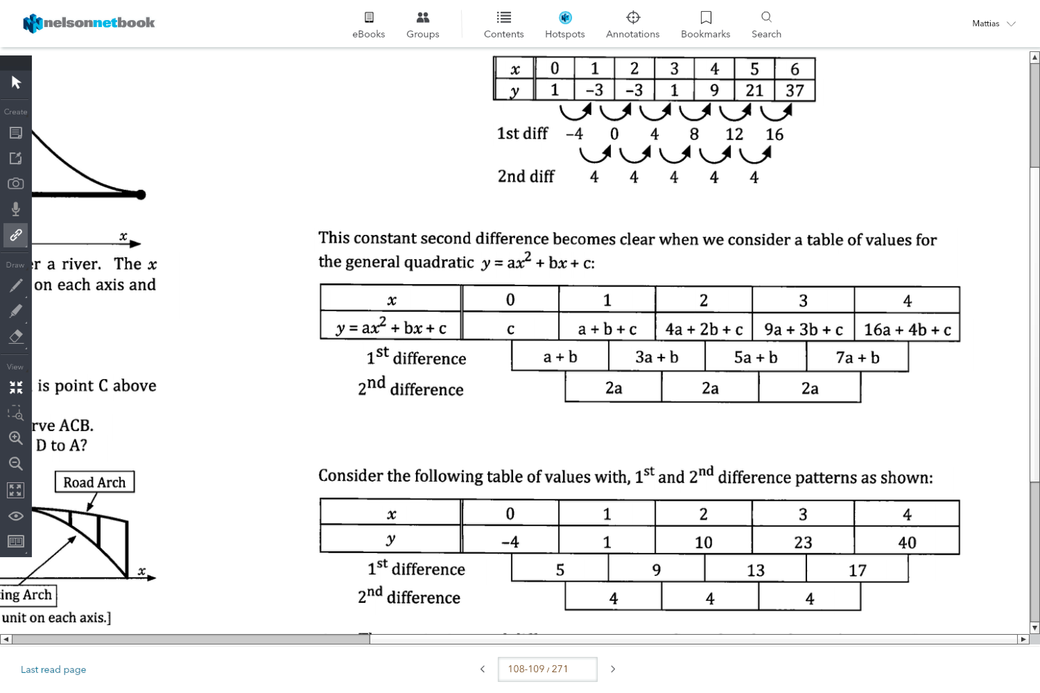

e.g.

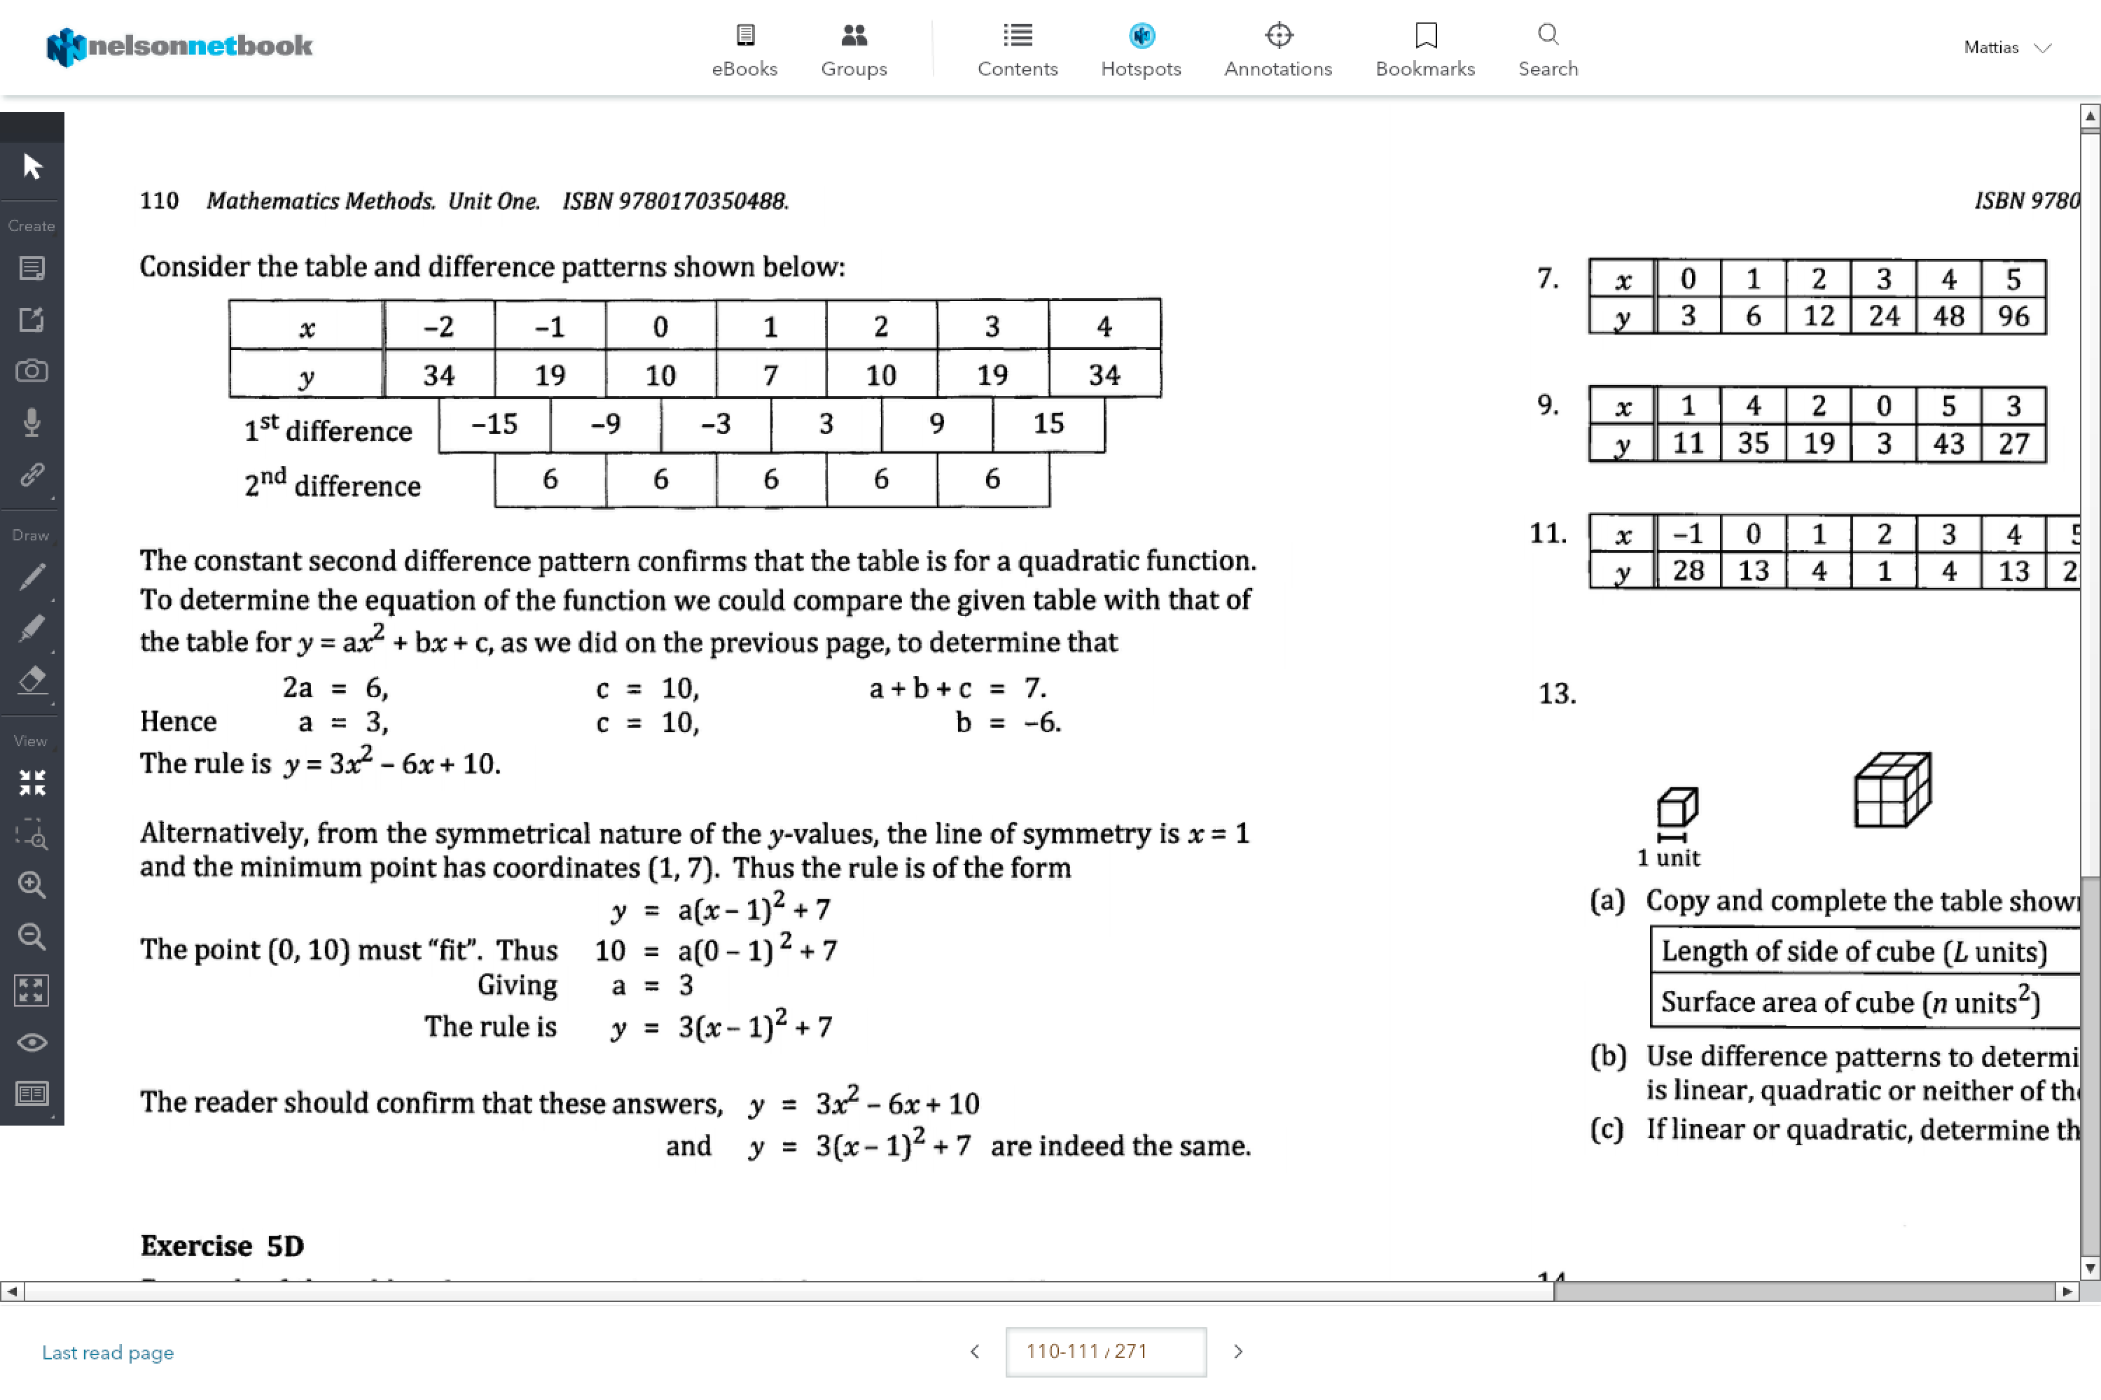

**Completing the Square:**

This is used to change from standard form to turning point form

1. We gap the equation
2. Then we add, and then subtract the square of half the coefficient of x
3. Then factorise

e.g.:

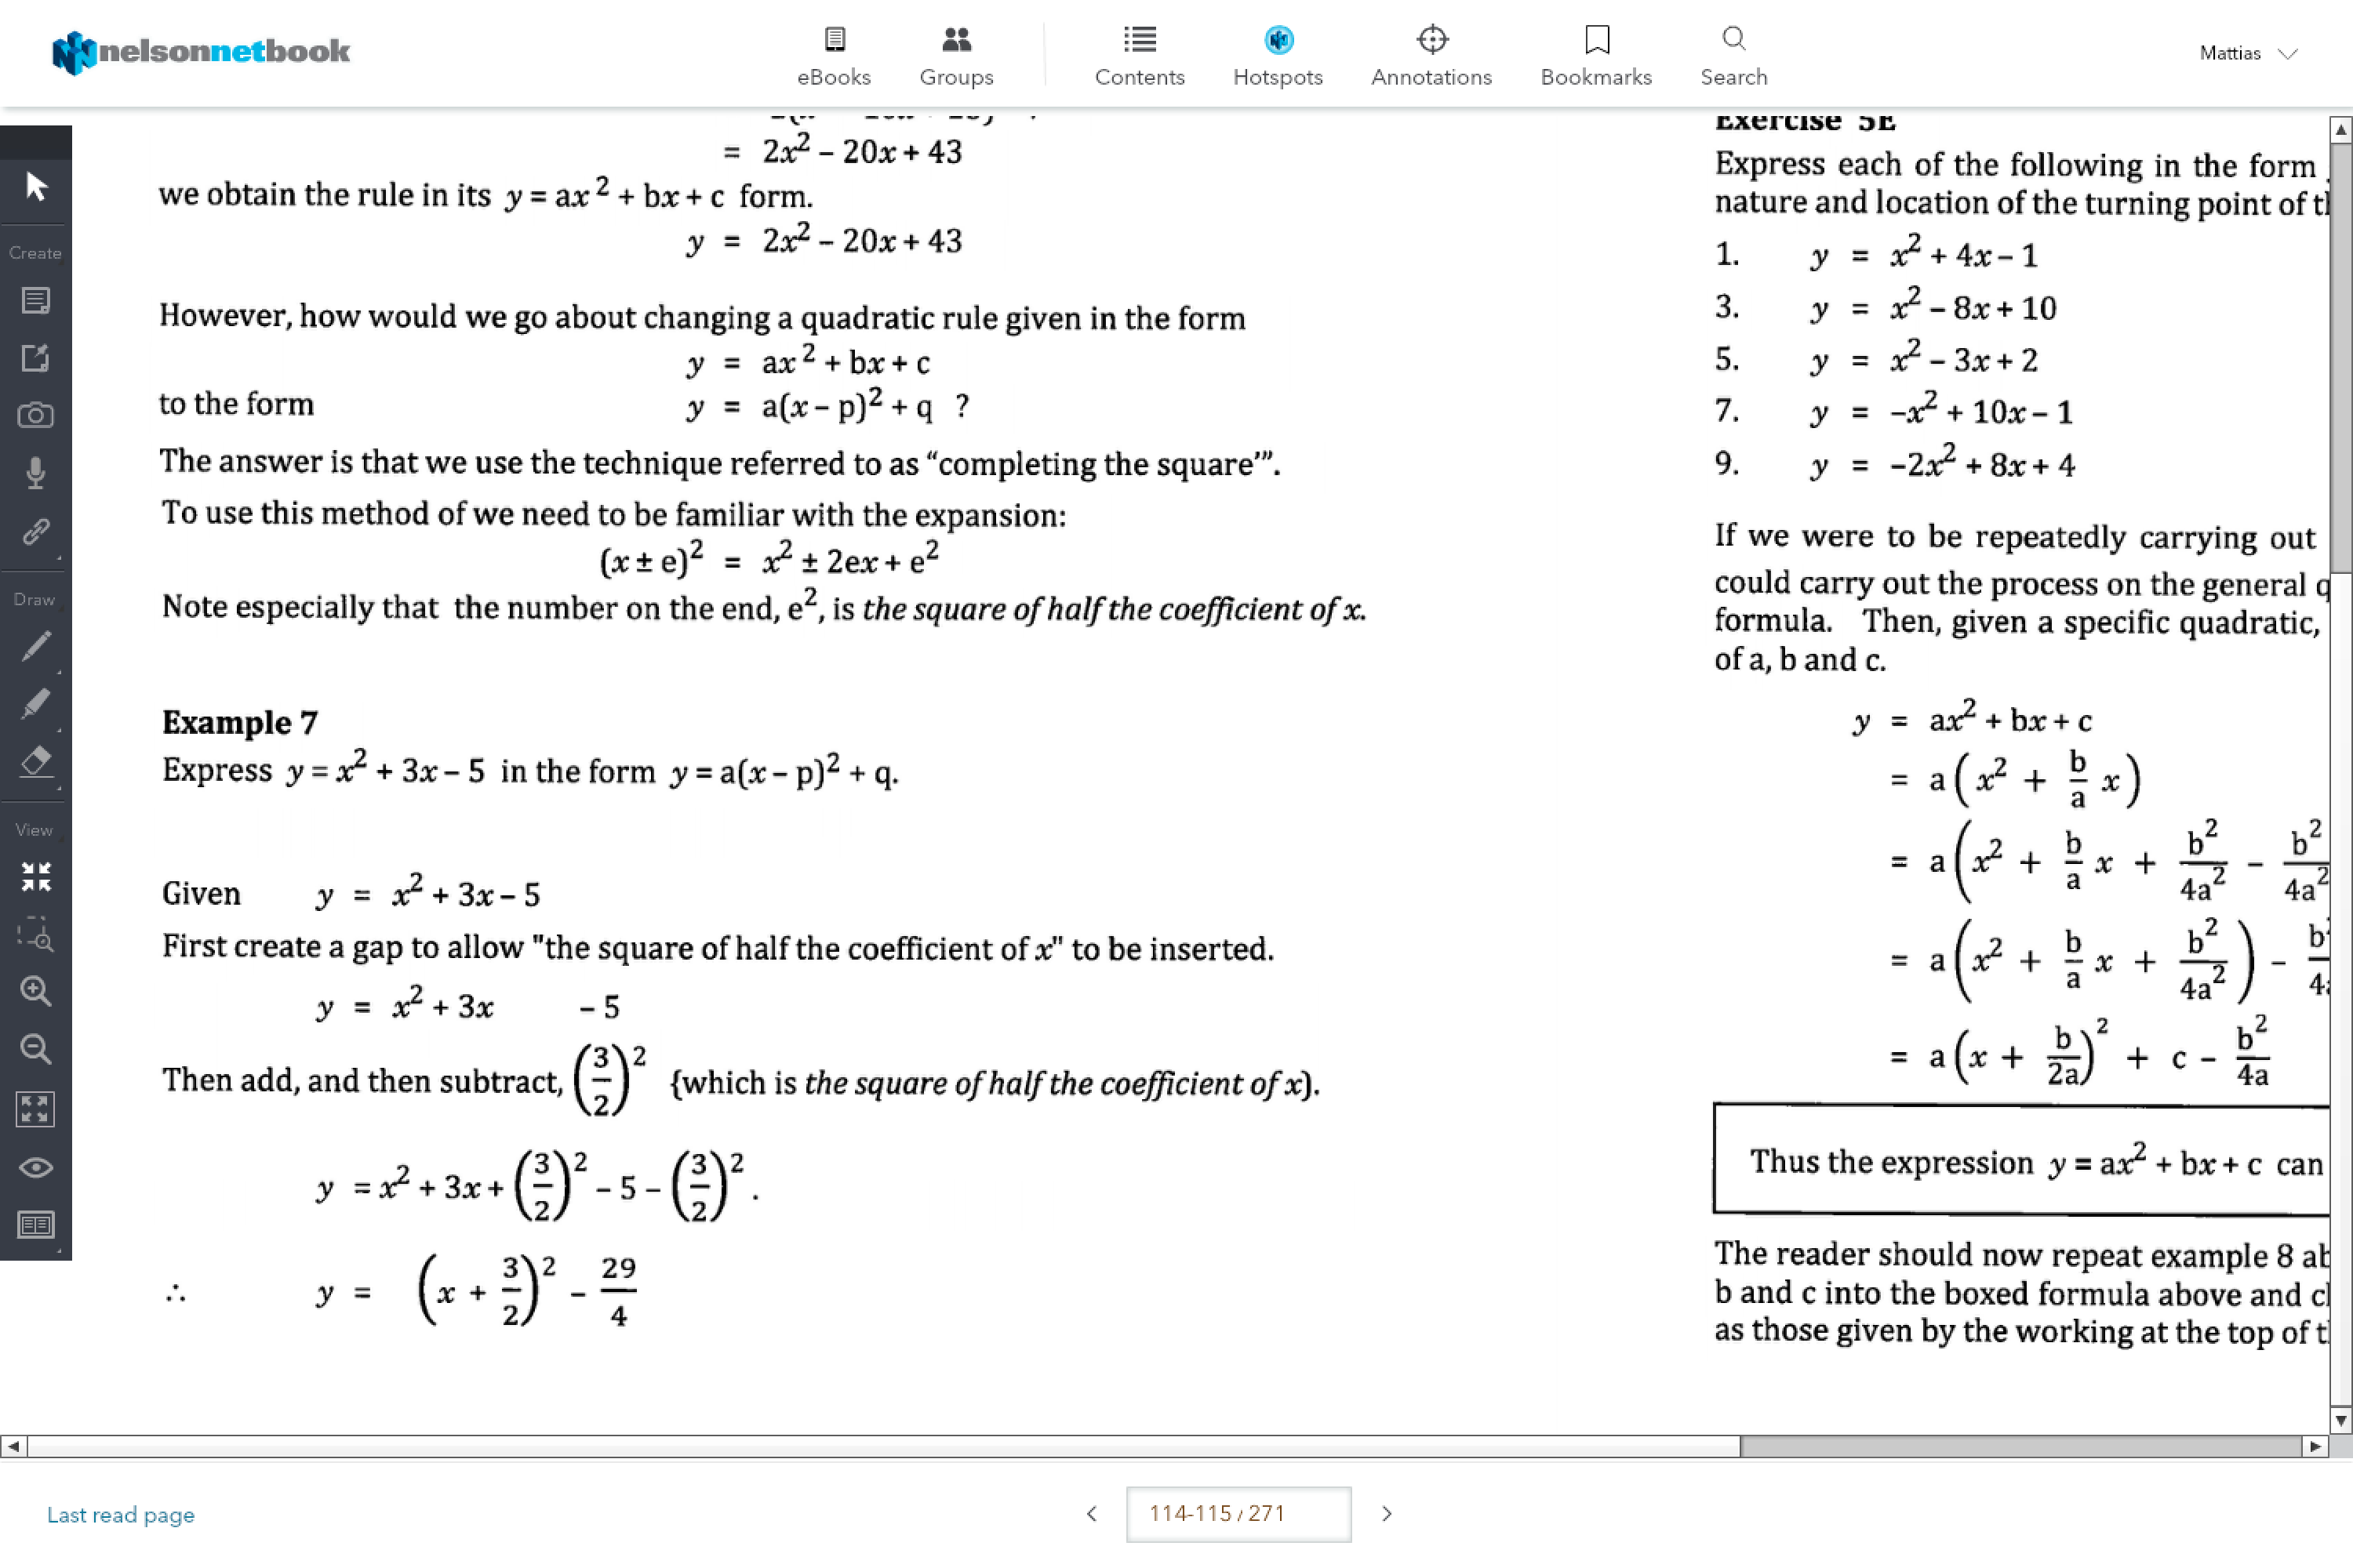

e.g.

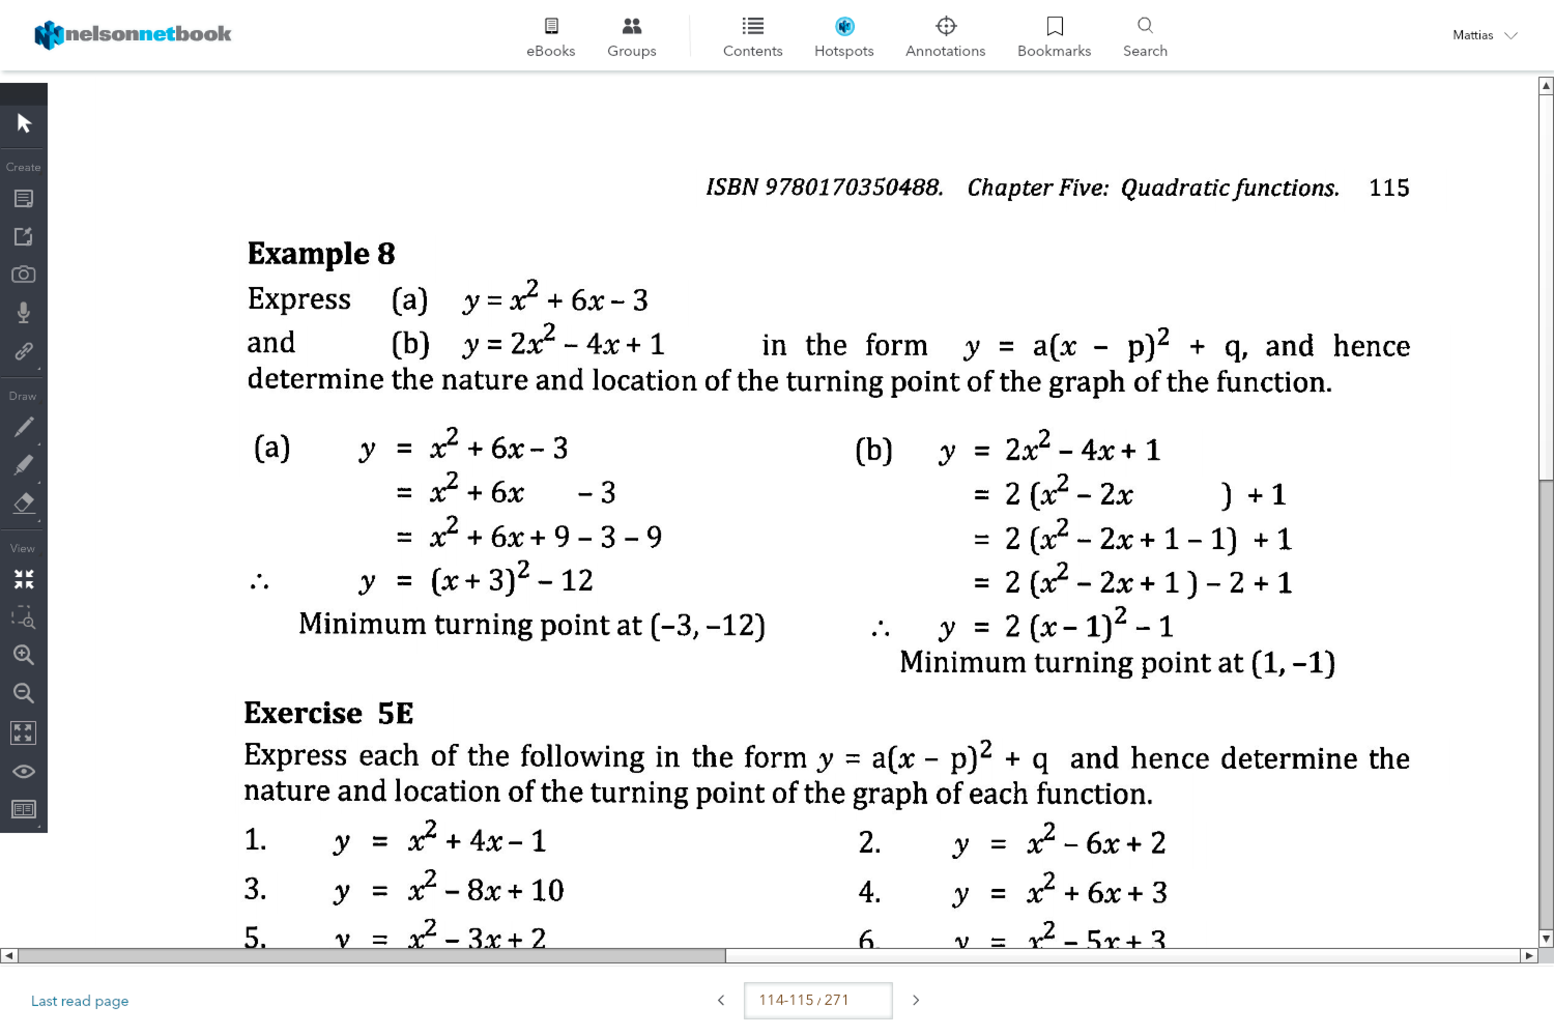

This leads to…

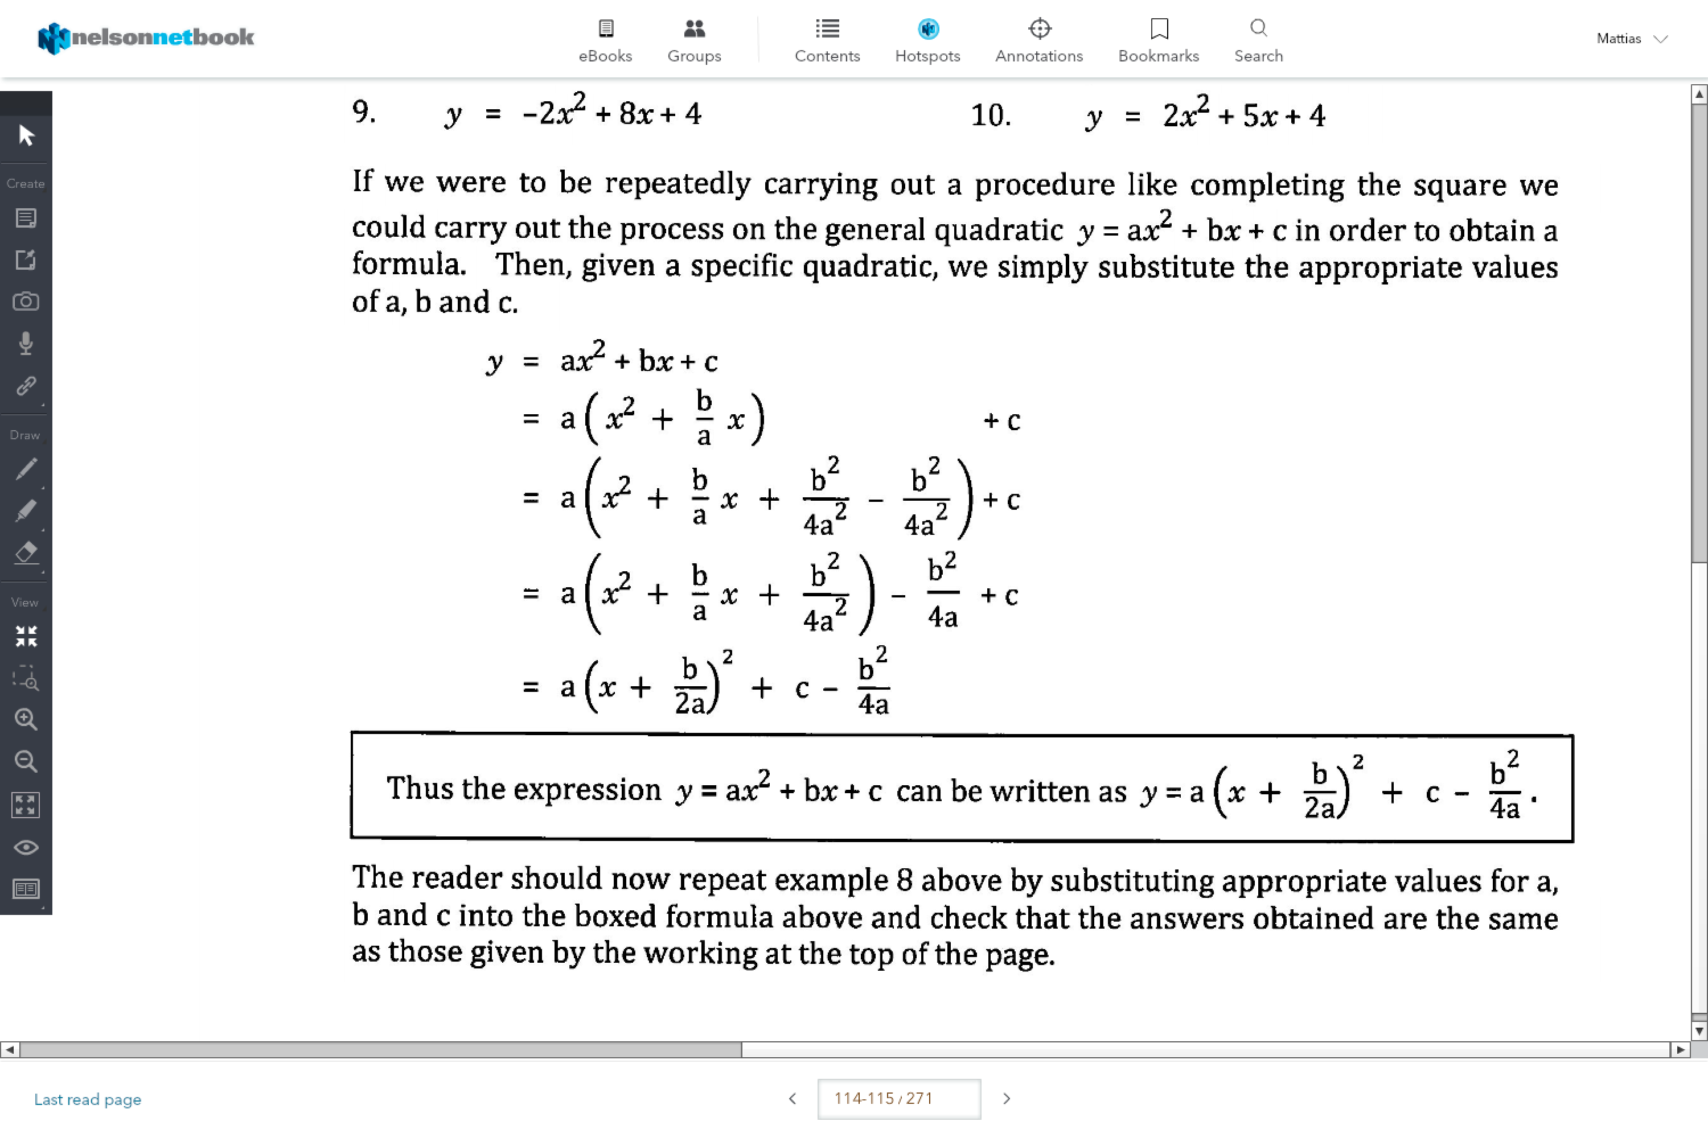

**Translation/ Changing:**

y=a[b(x-c)]2+ d

1. (B) Dilated parallel to the x-axis, scale factor 1/b

* (reflected in the y-axis if ‘b’ is negative)

1. (C) Translated c units

* (if c is negative, translated left)

1. (A) Dilated parallel to the y-axis, scale factor *a*

* (reflected in x-axis if ‘a’ is negative)

1. (D) Translated vertically upwards *d* units

* (if d is negative, translated downwards)